**CAPESTONE PROJECT**

**DATA TRANSFORMATION AND POWER BI DASHBOARD**

**TOPIC:**

**THE EFFECT OF GOVERNMENT AND INFORMAL TAX ON ROADSIDE TRADERS AND BUSINESSES**

***PREPARED BY***

**FRANCIS ESTHER OZIOMA**

**12TH JUNE, 2025**

**DOCUMENTATION ON THE FINAL YEAR CAPESTONE PROJECT**

**FROM**

**DATA ANALYSIS TRACK IN LMTECH**

**PRESENTED ON THE**

**12TH JUNE, 2025**

**TABLE OF CONTENT**

Cover Page - - - - - - - 1

Executive Summary - - - - - - - 4

Introduction - - - - - - - - 5

AIM - - - - - - - 6

Objectives - - - - - - 7

Data Source and Initial Challenges - - - - 8

Tools and Technologies - - - - - 9

Data Transformation Process - - - - - 9 – 11

Data Modelling in PowerBi(DAX) - - - - - 12

Dashboard Structure and Design - - - - - 12 – 22

Key Learnings - - - - - - - - 22

Future Enhancement - - - - - - 22

Recommendations - - - - - - - 23 – 24

Conclusion - - - - - - - - 24

References - - - - - - - - 25

# **Executive Summary**

This project focused on cleaning and analyzing real-world data on roadside traders and their tax experiences. The data was collected through a web survey form designed by the team I was assigned to and distributed to business owners both online and physical.

Using Excel Power Query and Power BI, I cleaned and transformed the raw data into a structured, analysis-ready format. This involved breaking down multiple response answers, converting them into simple 0/1 (yes/no) indicators, and ensuring no data was lost in the process.

Two interactive dashboards were created:

* One for **government policymakers**, highlighting tax patterns, compliance rates, and areas for policy improvement
* Another for **traders and advocates**, showing their tax experiences, concerns, and suggestions.

Notably, **34.2%** of traders being formally registered, **91.60%** still pay taxes, reflecting strong compliance by business owners.

The findings offer practical, data-driven recommendations to improve trust, service delivery, and encourage business formalization across Nigeria’s taxation sector.

# **Introduction**

The informal economy, particularly roadside trading, plays a critical role in Nigeria’s urban and semi-urban economic landscape. According to the *National Bureau of Statistics and the International Labour Organization*, the informal sector contributes over **50% of Nigeria’s GDP** and supports a significant share of employment, especially in local trade and services. Roadside traders form a visible and vital part of this sector.

Despite their contribution, this group is often underrepresented in official records, unregulated in terms of taxation, and frequently subject to informal levies and harassment.

To address this data gap and support evidence-based policymaking, our team designed a web-based survey targeting roadside traders and shop owners across multiple states **Anambra, Niger State, FCT-Abuja**, and more collecting responses from **500 traders** although the survey is still ongoing. The goal was to understand their demographic profiles, business operations, taxation experiences (both formal and informal), and daily challenges.

However, as is common with real-world survey data, responses were unstructured and inconsistent, many with multiple answers to single questions. This required a careful and rigorous data transformation process before any meaningful insights could be extracted.

This report documents the complete data cleaning, restructuring, and visualization journey, transforming raw survey inputs into a clear, interactive Power BI dashboard aimed at both government policymakers and business owners.

# **AIM**

To clean, transform, and standardize raw survey data into an analysis-ready format and develop interactive Power BI dashboards to deliver actionable insights for stakeholders.

# **Objectives**

* Convert categorical and range-based survey responses into structured numerical values.
* Handle multi-select responses by transforming them into binary indicator variables.
* Clean and standardize text entries by removing inconsistencies, symbols, and formatting errors.
* Build a reusable and scalable data transformation pipeline using Power Query.
* Validate transformed data to ensure accuracy, completeness, and reliability for decision-making.
* Develop interactive Power BI dashboards tailored to the needs of both government stakeholders and traders.

# **1. Data Source and Initial Challenges**

**Source of Data:**

The dataset was generated through a Google Forms survey targeting roadside traders and small business owners in states including Lagos, Delta, Kwara, Anambra, Niger, and the Federal Capital Territory (FCT) – Abuja. Upon completion, the responses were exported as an Excel file for cleaning, analysis, and further insights.

**1.1 Survey Context & Human Realities:**

While the survey was designed to be anonymous and non-intrusive, engaging with respondents on the ground presented a number of human challenges. Many traders expressed skepticism and concern, fearing the survey might lead to increased taxation or unwanted government attention. Others were simply disillusioned by the current tax system and declined participation altogether.

To overcome these barriers, my team and I adopted a more personal approach speaking directly with respondents, building trust, and clarifying that no personal data was being collected. We emphasized that the goal was to understand their realities better, not to expose them to penalties or regulation.

**2. Complexity of the Dataset:**

The survey comprised of 26 questions covering key areas such as business type, location, tax payment patterns, challenges with public services, and general perceptions. This produced a multi-layered dataset that required careful transformation and cleaning before it could be used for analysis.

**2.1 Key Data Challenges Identified:**

* **Categorical Ranges:** Fields like age groups (“18–25”, “25–30”) and years in operation (“More than 10 years”) needed to be standardized for consistency.
* **Inconsistent Binary Responses:** Yes/No questions were answered using a mix of formats such as “Y”, “yes”, “YES” which needed to be harmonized.
* **Currency Formatting Issues:** Monetary values were sometimes entered with symbols (₦) or commas, requiring cleaning and conversion to numeric values.
* **Multi-select Responses:** Some questions allowed multiple answers stored as comma-separated text (e.g., “Arrest or detention, Seizure of goods or equipment, Forced closure of business”), which had to be split into individual binary indicators for analysis.
* **Text Inconsistencies:** Variations in spelling, capitalization, and spacing were common in categorical responses and needed to be cleaned for accuracy.
* **Sparse Free-text Fields:** While open-ended comment fields were included to gather additional context, many were left blank or contained vague or non-actionable feedback.

# 

# **3. Tools and Technologies**

**3.1 Power Query & M Language (Excel):**

Power Query made the data cleaning process much easier and more visual. With it, I was able to fix messy entries, standardize inconsistent responses, and break down the data into something more structured and useful.

One of the challenges I faced was working with columns that had multiple responses in one cell (for example, checkboxes where respondents picked more than one option). I was able to handle this by:

* Splitting the responses into separate rows
* Adding index numbers to track and later reconnect the original records
* Unpivoting and pivoting columns to turn those split responses into simple 0s and 1s, so they could be analyzed individually
* Using the Group-By function to remove duplicate rows and summarize values correctly after pivoting. This step was important to ensure the final dataset didn’t inflate row counts and gave accurate totals for analysis.

In the background, Power Query’s M Language helped automate many of these steps, allowing me to focus more on insights rather than manual cleanup. Overall, Power Query played a huge role in transforming a messy dataset into a clean, analysis-ready format.

**3.2 Power BI Desktop & DAX:**

Power BI was used to bring the cleaned data to life through clear, interactive visuals. It made it easy to explore trends, compare groups, and tell the real story behind the numbers.

To go beyond basic charts, I used DAX (Data Analysis Expressions) to create custom measures like averages, percentages, etc. helping uncover deeper insights that weren’t immediately visible.

These tools were chosen because they work seamlessly together. Power BI handled the visuals, while DAX took care of the smart calculations. Together, they made it much easier to turn raw survey data into meaningful, decision-ready insights for both policymakers and business owners.

# **4. Data Transformation Process**

**4.1 Categorical to Numerical Conversion:**  
To make analysis easier, ranges and categories were converted to numerical values using their midpoints. For example:

Age group **“18–25 years”** was mapped to **21.5**

Daily profit range **“₦1000–₦2000”** was converted to **₦1500**

Number of workers like **“3–5”** was changed to **4**

This helped in calculating meaningful averages and visualizing trends more clearly.

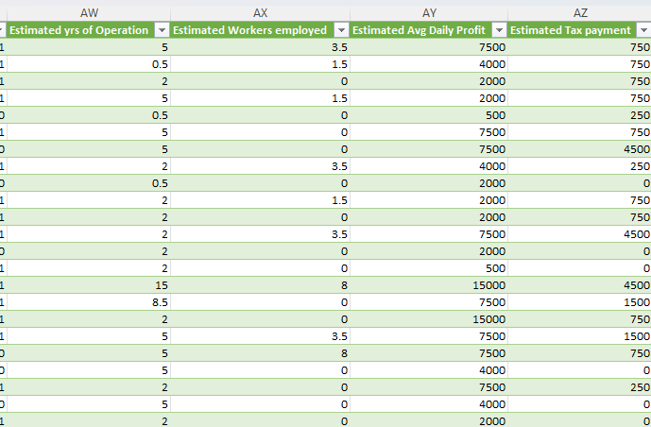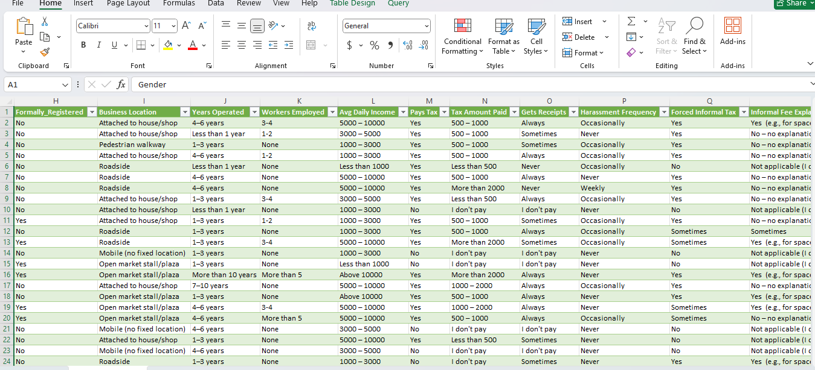

# **4.2 Handling Multi-Select Responses**

Some survey questions allowed respondents to choose multiple options, which were stored as comma-separated text in a single cell. To make the data easier to analyze, these responses were split into separate binary (Yes/No) columns.

**Example 1 – Payment Frequency:**

* **Before:** *“Daily/ticket, Weekly, Monthly, Yearly”*
* **After:**
  + Daily/ticket
  + Weekly
  + Monthly
  + Yearly

Each option became its own column, marked to show whether it was selected.

**Example 2 – Tax/Levy Collectors:**

* **Before:** *“Local Government Officials, Taskforce agents, Union representatives, Touts or unidentified individuals, None”*
* **After:**
  + Local Government Officials
  + Taskforce agents
  + Union representatives
  + Touts or unidentified individuals
  + None

This transformation allowed us to count how often each group was mentioned and identify patterns across different locations or business types.

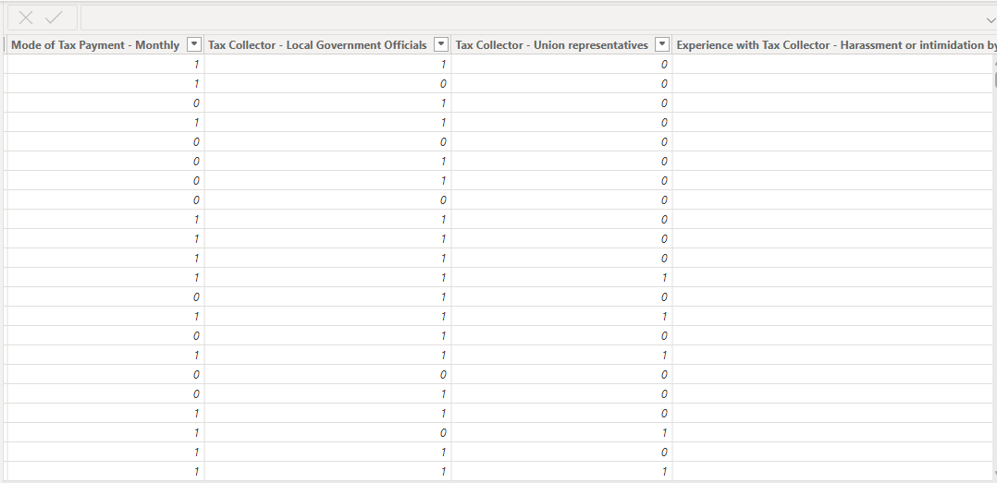

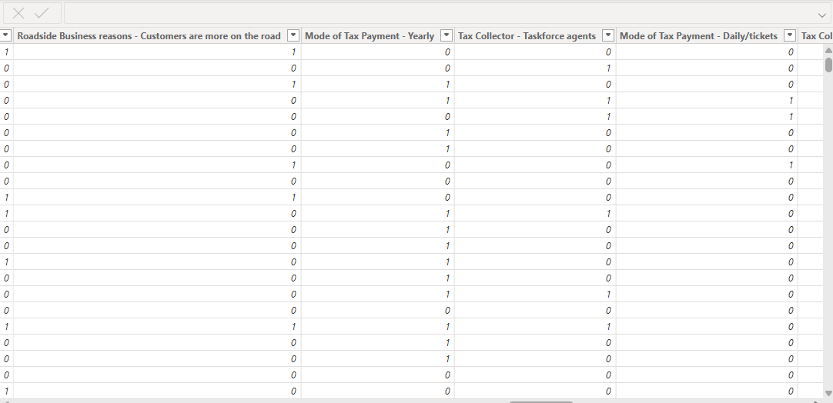

## **4.3 Text Column Standardization:** To ensure consistency across categorical text fields, several formatting operations were applied:

## **Trim:** Removed leading and trailing whitespaces.

## **Capitalize Each Word:** Standardized casing (e.g., 'Niger state' → 'Niger State').

## **Replace Values:** Fixed typos and inconsistent spellings (e.g., 'Y' → 'Yes')

## However, these transformations preserved the categorical nature of the data while enabling effective filtering and grouping in Power BI.

## **4.4 Column Removal:** The open-ended *'Comment'* field, the *'Timestamp'*, and an additional error column (which was mistakenly included without an associated question) were removed due to their sparse entries and high proportion of null values. Although the 'Timestamp' indicated when each respondent completed the form and could provide qualitative insights, it was excluded from this quantitative analysis to streamline the dataset and minimize noise.

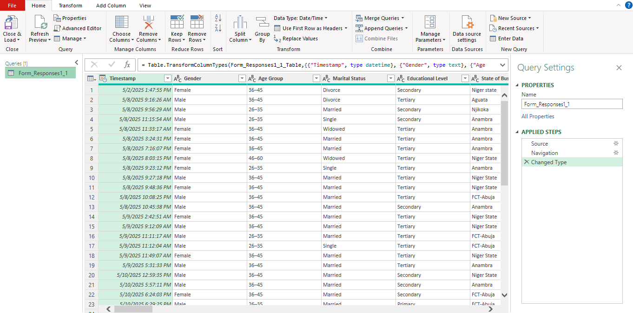

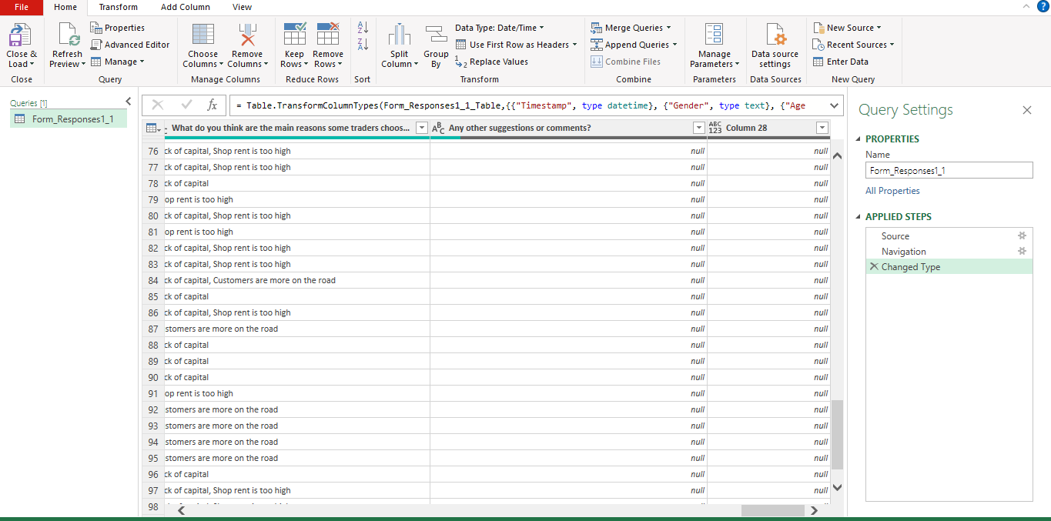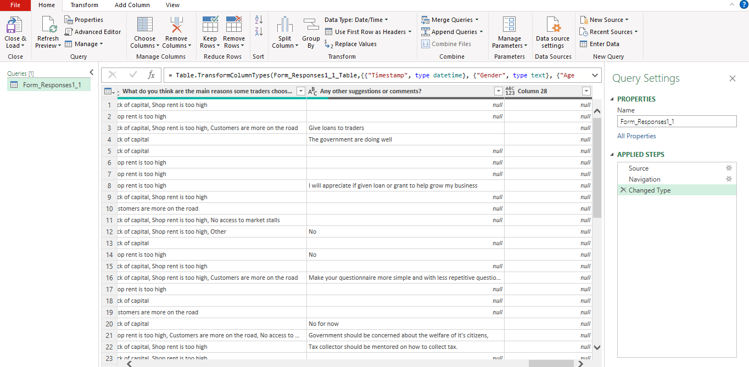

# **5. Data Modeling in Power BI (DAX)**

After cleaning and transforming the data in Power Query, the dataset was loaded into Power BI Desktop for deeper analysis and visualization. Several custom **DAX (Data Analysis Expressions)** measures were created to power the dashboard’s insights.

**Examples of Key Measures:**

* **Total Traders** = COUNTROWS('Form Responses 1') → Used to show the total number of respondents on a KPI card.
* **Average Daily Income** = AVERAGE('Form Responses 1'[Estimate Avg daily profit]) → Displayed as a key metric to assess the income level of traders.
* **Average Daily Tax Paid** = AVERAGE('Form Responses 1'[Estimated Tax amount Payment]) → Helped visualize the average tax burden across the sample.
* **Avg Tax Rate** = DIVIDE(AVERAGE([Estimated Tax Payment]), AVERAGE([Estimate avg daily profit]), BLANK()) → Used in a KPI visual to highlight the proportion of income going to tax.
* **% Businesses Registered** = DIVIDE(Count of Registered, Total Traders)  
  → Illustrated the percentage of formalized businesses.
* **% Traders Paying Tax** = DIVIDE(COUNTROWS where [Pays Govt Tax] = "Yes", Total Traders) → Showed how many traders actually paid government taxes.
* **Potential Income & Tax Paid if Registered** → Averages were calculated for registered businesses to compare performance against unregistered ones. etc…

**5.1 Practical Application:**

These DAX measures powered visual elements like KPI cards, bar charts, and comparison visuals, making the dashboard dynamic and insightful. They allowed stakeholders to quickly spot trends such as how tax payment relates to business registration or income levels.

**5.2 Challenges Faced:**

One common issue was handling blank or missing values, especially when calculating tax rates using the DIVIDE function. This was addressed by including a fallback (BLANK()) to avoid errors and ensure cleaner visuals.

# **6. Dashboard Structure and Design**

The Power BI dashboard was split into two main pages to serve the needs of two distinct audiences and also make the analysis more interactive and insightful.

**Page 1: Government & Policy Makers**

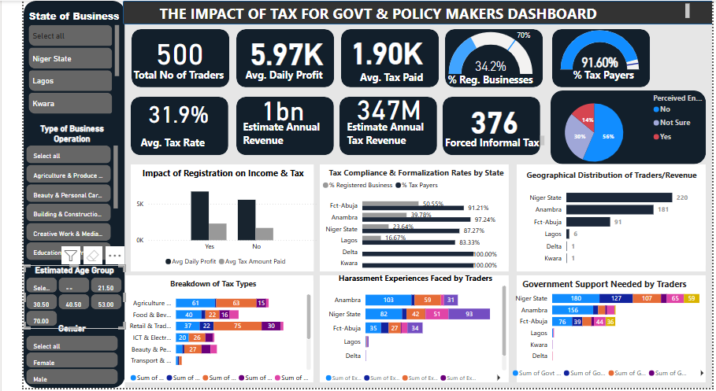

**6.1.1 Purpose of the Dashboard**

This page is designed to help government officials and policymakers understand what’s really happening with informal traders, especially around registration, taxes, and the kind of support they need. It offers a bird’s eye view of where the gaps are and what traders are going through on the ground, so that future decisions can be more focused and fair.

**6.1.2 Key Visuals Included:**

* **KPI Cards (Top Row)**:
  + **Total No. of Traders**: 500
  + **Avg. Daily Profit**: ₦5.97K
  + **Avg. Tax Paid**: ₦1.90K
  + **% Registered Businesses**: 34.2%
  + **% Tax Payers**: 91.60%
  + **Avg. Tax Rate**, **Estimated Annual Tax Revenue**, and **Forced Informal Tax Cases** were also highlighted for instant visibility.
* **Bar & Column Charts**:
  + *Impact of Registration*: Compares average income and tax between registered and unregistered businesses.
  + *Tax Compliance by State*: Shows both registration and tax payment rates by state.
  + *Government Support Needed*: Highlights the top areas traders need intervention (e.g., combine multiple levies, Give grant, Provide mentorship etc.).

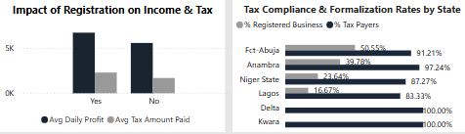

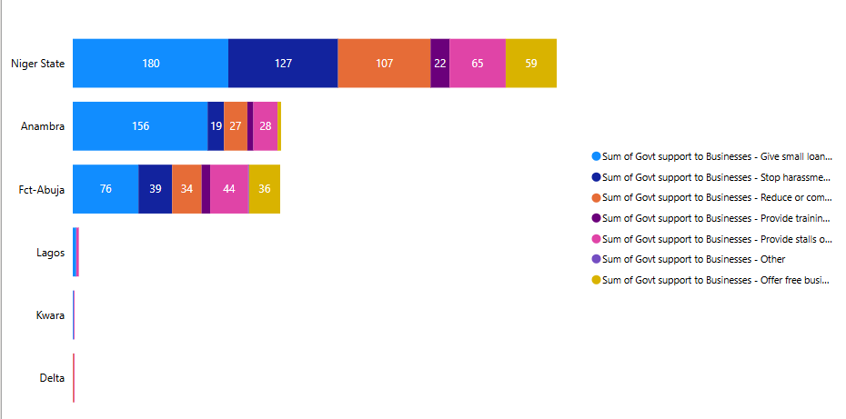

* **Pie Chart**:
  + 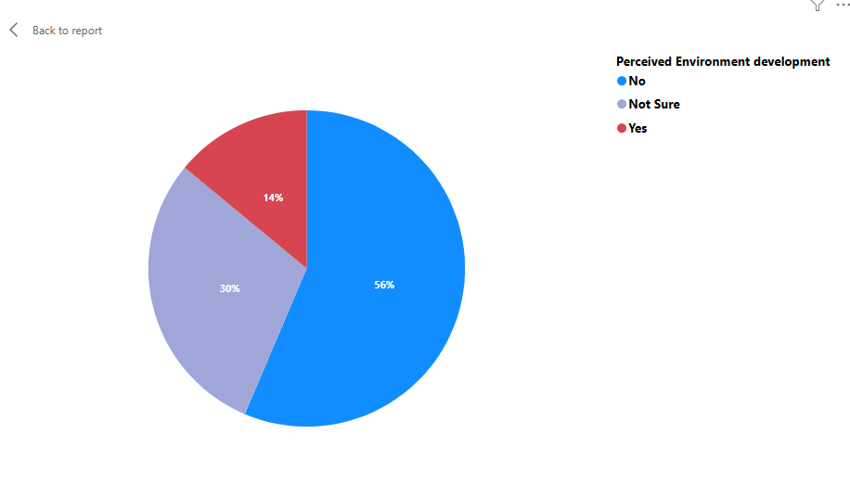Captures **Perceived Environmental Development** (e.g., “No,” “Not Sure,” “Yes”).
* **Stacked Column Charts**:
  + *Breakdown of Tax Types*: Groups like Agriculture, Food, Retail were analyzed for how many paid daily, weekly, etc.
  + *Harassment Sources*: Shows traders’ experiences with different tax or enforcement agents.

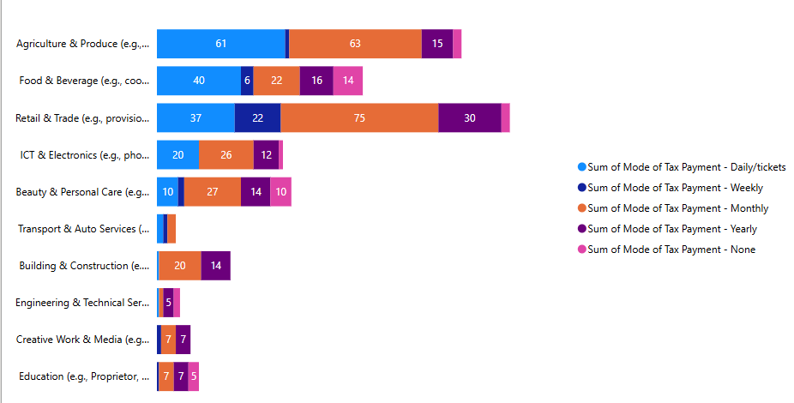**Breakdown of Tax Types**

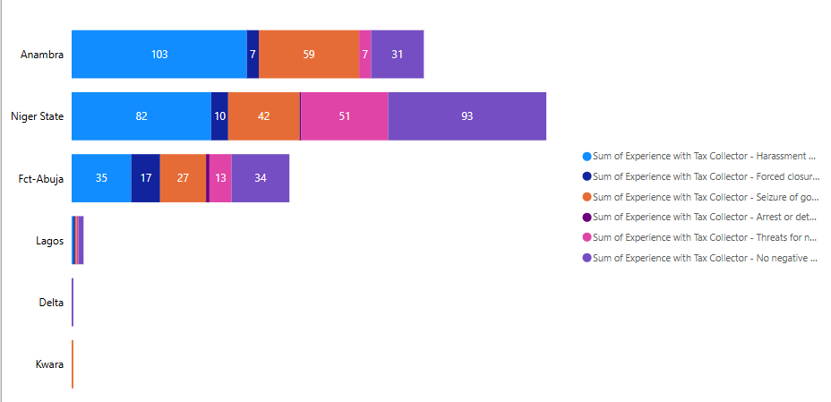**Harassment Experiences Faced by Traders**

* **Geographical Distribution**:
  + Highlights the number of traders and estimated revenue across different states.

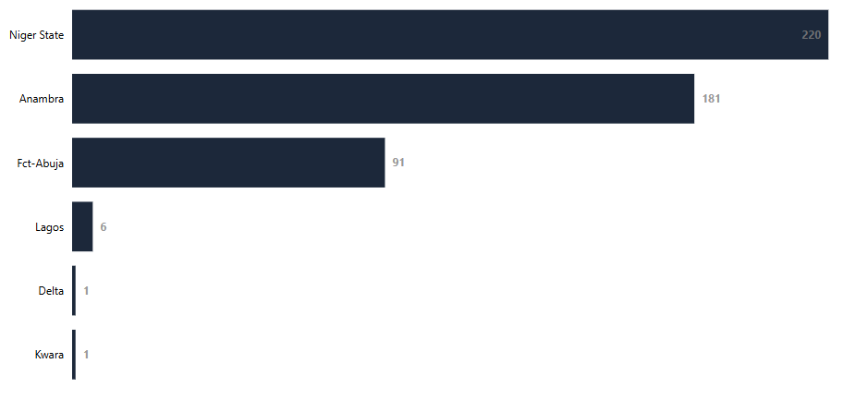

**6.1.3 Interactive Features:**

* **Filters (Left Panel)**:

Users can filter the data by:

* + **State of Business**
  + **Type of Business Operation**
  + **Estimated Age Group**
  + **Gender**

These filters enable policymakers to drill down into specific demographic or regional patterns.

**6.1.4 What the Numbers Tell Us:**

Here are some key takeaways from the dashboard:

* **500 traders** were surveyed across different states although the survey is still ongoing. Data are still on collection from business owners.
* On average, they make about **₦5,907 in profit per day**, but pay **₦1,900 in tax** daily which is **over 31.9% of their earnings**.
* Only **34.2% of the businesses are registered**, yet **over 91.60% pay taxes** anyway. This shows that formal registration is still low, but tax collection is happening one way or another.
* The **estimated total yearly revenue** from these businesses is around **₦1billion**, with about **₦347 million potentially going to tax**.
* Worryingly, **376 traders reported being forced to pay informal taxes or levies**, which points to serious issues of harassment or unofficial collections.

**6.1.5 Insights From the Charts**

**(a) Registration vs. Income**

Businesses that are registered seem to earn more and have better tax practices. This suggests that registration might actually be helpful not just a requirement, but a step toward growing and protecting a business.

**(b) State-by-State View**

The chart reveals significant variations in tax compliance and business formalization across states. Kwara and Delta show the highest rates, with **100% of respondents both registered and paying taxes**. However, it's important to note that **Delta had very few respondents**, which may limit the generalizability of its data.

**Lagos**, despite its economic prominence, shows relatively **low business registration (16.67%)** but a **higher tax compliance rate (83.3%)**, suggesting many unregistered businesses are still paying taxes. **FCT-Abuja** follows with a **moderate registration rate (50.55%)** and **high tax compliance (91.21%)**.

In contrast, **Niger State** and **Anambra** display **low formal registration rates (23.64% and 39.78%, respectively)**, indicating a **prevalence of informal businesses**. These states, despite having high tax compliance rates (87.27% and 97.24%), may benefit from targeted **awareness campaigns and support initiatives** to encourage business registration.

This data can help guide where government efforts should focus to improve business formalization and support inclusive tax systems.

**(c) Harassment and Safety**

A good number of traders, especially women, reported facing harassment or being asked for unofficial payments. This shows that creating safer and more organized market environments is a priority.

**(d) Types of Taxes Paid**

Traders in sectors like retail, food, agriculture, and ICT are paying multiple forms of taxes. Many of these businesses are small and operate with low margins, so there’s a clear need to simplify taxes or offer some relief.

**(e) Support Traders Want**

When asked what kind of support they need, traders were clear:

* Access to grants or financial help
* Better infrastructure (like cleaner markets, stalls, roads)
* Protection from harassment
* Easier registration processes

**6.1.6 Perception of Government Efforts: What Traders Are Saying**

While many traders are paying taxes and levies, a large number don’t feel the government is fulfilling its end of the bargain. According to the data:

* **56% of respondents** believe that taxes paid are not used to improve their environment.
* **30% are unsure**
* Only **14%** believe taxes are making a positive difference

Digging deeper into responses by having a one-on-one conversation with some of the respondents, especially from **Niger State** and **some local markets in FCT-Abuja**, several traders expressed strong concerns:

* Sanitation fees are paid, but during the rainy season, water often brings large amounts of dirt and debris into their shopfronts. Despite paying, traders still sweep the mess themselves and hire waste collectors often using their own money. This cleaning happens not just during rainy seasons but almost daily in some locations.
* The same applies to fumigation fees. Some traders reported that they pay regularly for fumigation, yet no fumigation is done, and cockroaches and pests remain a daily issue in their shops.

These lived experiences paint a clear picture: many traders feel like they’re paying, but not receiving the services they’re promised. This gap between payment and service delivery creates frustration and erodes trust in the system.

**6.1.7 What This Means for Policy Markers and Practice**

To restore trust and improve tax compliance among traders, especially in local markets across Niger State and parts of FCT-Abuja, government agencies must go beyond collecting fees. It’s essential that services like sanitation, fumigation, and drainage already being paid for are consistently delivered and clearly visible.

When traders see tangible improvements in their environment, they’re more likely to feel supported, comply with taxes, and even pursue formal registration. But when services lag behind payments, trust erodes, and informality persists.

Going forward, a more transparent, responsive approach is needed. The approach that not only delivers services but also involves traders in planning and feedback. This is how we shift from mere compliance to genuine cooperation, paving the way for healthier, safer marketplaces and stronger local economies.

**Page 2 - Business Owners / Traders:**

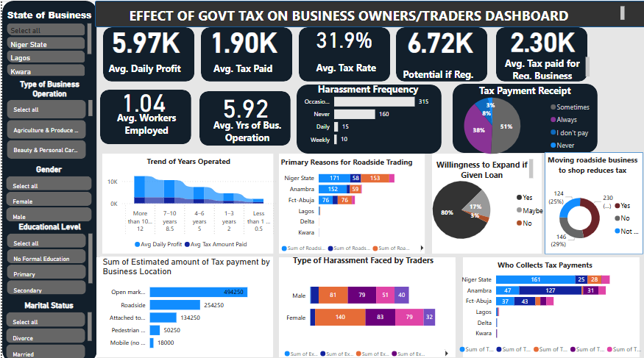

**6.2.1 Behind the Numbers: The Everyday Reality of Taxed Traders**

*Insights from the Business Owners & Traders Dashboard*

This dashboard brings to light the lived realities of business owners and traders across Niger State, Lagos, Kwara, and parts of FCT-Abuja. It’s not just numbers, it’s a reflection of how policies are playing out in the daily lives of people trying to make a living.

**6.2.2 Quick Stats at a Glance**

* **₦5.97K** – Avg. Daily Profit
* **₦1.90K** – Avg. Tax Paid
* **31.9%** – Avg. Tax Rate
* **₦6.27K** – Potential Profit If Registered
* **₦2.30K** – Avg. Tax Paid by Registered Businesses
* **1.04** – Avg. No. of Workers
* **5.92 Years** – Avg. Time in Business

These figures already suggest that taxes take a significant chunk of daily earnings and yet, many traders are still operating informally or under-registered.

**6.2.3 How Traders Can Use This Dashboard:**

* **Filter by Gender, State, or Business Type**

For instance, a female trader in FCT-Abuja can filter to see what her peers are earning, paying, and experiencing, making the dashboard feel personal and relevant.

* **Make Informed Choices**

Traders considering registering their businesses can compare average income, harassment rates, and tax levels between formal and informal operations.

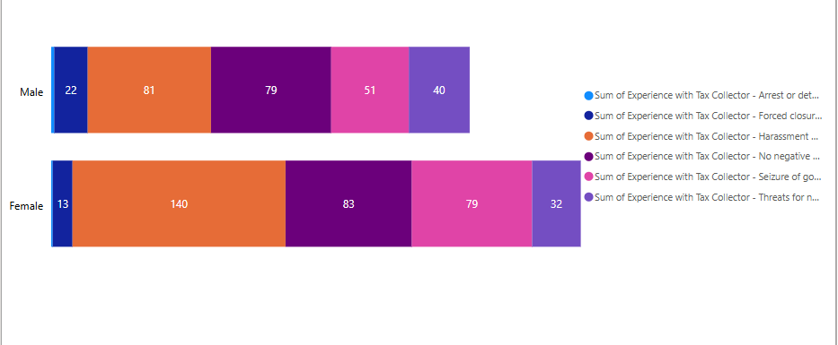**Type of Harassment Faced by Traders (Gender)**

**Primary Reasons for Roadside Trading**

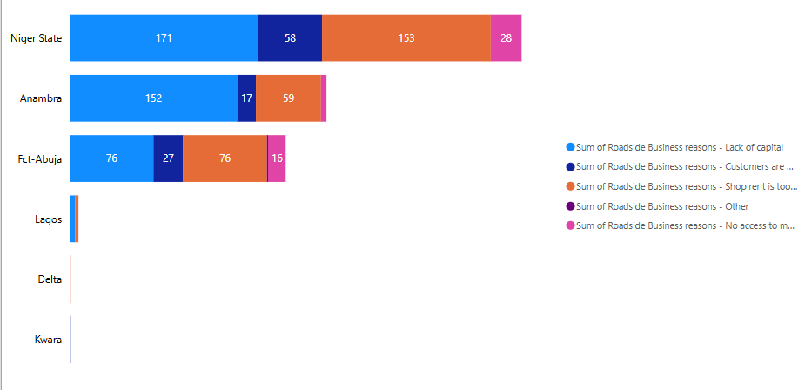

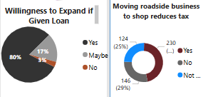

* **Understand Their Value**

The dashboard illustrates how much traders contribute through taxes and how much more they could if given better support or formal opportunities.

**6.2.4 Tax and Trust: A Fragile Balance**

While taxes are collected regularly, many traders feel they get little or nothing in return. According to the data:

* **56% say government taxes do not improve their environment**
* **30% are unsure**
* Only **14% believe taxes are making a positive difference**

And when you listen to their stories especially in **Niger State** and local markets in **FCT-Abuja**, a pattern emerges just as seen in (**7.1.6 content)**.

**6.2.5 The Roadside Trading Isn’t Always by Choice**

One of the most striking revelations: **over 60%** of traders says moving from roadside stalls to formal shops doesn’t reduce their taxes. In fact, many claim it increases the burden.

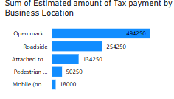“The moment you get a shop, your taxes go up.”

The data supports this:

* Open market locations: ₦494,250 (highest estimated tax payments)
* Shops attached to buildings: ₦134,250
* Roadside traders: ₦254,250
* Pedestrian traders: 50,250
* Mobile sellers: ₦18,000

So while shops may offer more structure, they come with higher taxes, steep rent, and still no guarantee of better services.

Some traders would love to move into proper shops for better security and comfort but can’t afford the high rent nor have the capital to start off business in a shop space.

Others stay roadside because customers find them more easily.

Whether it’s a kiosk, stall, or shop, traders feel the burden remains or gets worse.

Location doesn’t change the struggle sometimes, it even makes it harder**.**

In essence, to move the needle on tax compliance and business formalization, the government must go beyond revenue collection. From analysis we can see that traders are willing to contribute but they need to see where their money is going.

When traders feel part of the system and not just subject to it compliance goes up, informality goes down, and trust is restored.

# **7. Key Learnings**

Although the data was collected as a team through field surveys, I took on the task of cleaning, transforming, and analyzing it on my own and it was both eye-opening and challenging.

**Key Learning:**

* **Test As You Go:**

I adopted a step-by-step testing approach in Power Query. Instead of waiting until the end to validate transformations, I reviewed each step. It saved me from bigger problems later.

* **M Language is Small but Mighty:**

Learning to use M was a game-changer. I used it to convert age ranges like “18–25” into midpoints like 21.5, and did the same for profit ranges. These small tweaks made analysis much more meaningful.

* **The Importance of Context:**

Creating dashboards that would make sense to both government officials and business owners meant thinking beyond numbers using language, filters, and visuals that aligned with each audience’s reality.

* **Feedback Sharpens Insight:**

Even though the analysis was done independently, input from the data collection team helped clarify some responses and gave context to what traders were actually saying.

# **8. Future Enhancements**

- Auto-refresh with new form responses  
- Personalized benchmarking  
- Drill-through pages  
- Custom tooltips  
- Performance tuning

**Recommendations**

**1. Show That Business Registration Leads to Real Growth**

Many traders still see registration as just another government formality with little benefit. But the data says otherwise. From the analysis we can see that registered businesses often earn more, grow faster, and are more consistent with tax payments.

Registration isn’t just a checkbox, it’s a gateway to recognition, stability, and bigger opportunity. A registered business is more likely to access:

* Government support like grants, loans, or intervention funds
* Training and capacity-building programs
* Legal protection from eviction or harassment
* Bigger business opportunities that require official documentation

To change how traders perceive registration, the government must make the registration process simpler, cheaper, and more visible in its benefits. Awareness campaigns should highlight real-life success stories of small businesses that grew after formalizing. This is how registration can shift from feeling like a tax trap to being seen as a path to growth and legitimacy.

**2. Connect Taxes to Real, Visible Services**

When traders see improvements like cleaner markets, waste removal, or better drainage, they’re more willing to pay taxes. People need to feel that what they pay is coming back to benefit their businesses and communities.

**3. Train Tax Agents to Support, Not Scare**

Tax agents should be seen as helpful guides, not enforcers. When agents explain, listen, and support, they build trust and that trust leads to better long-term compliance.

**4. Build a Simple Tax Tracking App That Traders Can Trust**

Many traders don’t have a clear record of the payments they make whether it’s sanitation fees, union dues, or local levies. They pay, but they often forget how much, who collected it, or whether it was even official. That lack of transparency creates room for confusion, double-charging, and even exploitation.

Now imagine a simple mobile app designed just for them that acts like a personal tax diary. With this app, traders could:

* Log every payment made, formal or informal
* Get instant receipts from approved agents
* Track how much they've paid over time
* Learn about their tax rights and state policies
* Even receive reminders to register their business or do it right there in the app

And it doesn’t stop there. For traders with basic phones or low literacy, there could be a **USSD** version, voice support in local languages, and trained agents in markets to help them use it.

This app wouldn’t just serve traders it would serve the government too. By gathering real-time data, states can detect irregular fees, adjust policies, and better support small businesses.

At its heart, this app is about building trust and transparency. When traders feel informed, protected, and respected, they’re more likely to engage not just with the app, but with the entire tax system.

# **Conclusion**

This project began with a simple goal, to cut through the noise, clean the data, and surface the realities that traders and policymakers face every day. What emerged wasn’t just charts or numbers. It was a story of imbalance, resilience, and opportunity.

For government stakeholders, the dashboards reveal long-standing challenges, low business registration, fragmented and often informal tax systems, and a widespread disconnect between what traders pay and what they receive. In states like Niger and parts of Abuja, traders contribute through levies for sanitation or fumigation, yet many see little evidence of those services. This lack of visible return fuels distrust and keeps many outside the formal system.

For traders, the data reflects a hard truth, most roadside businesses are built not from choice, but from necessity. To them, formalization often feels like a cost with no benefit a step that brings more rules but not more value. They are willing to comply, but only if fairness and real support follow.

If governments truly want higher compliance and formalization, the answer isn’t more pressure it’s more partnership. Cleaner markets. Honest enforcement. Simple tools. Human connection. When traders feel seen and supported, they respond in kind.

**References**

International Labour Organization. (n.d.). *Informal economy in Nigeria: Employment trends and MSME contributions*. Retrieved from <https://www.ilo.org>

National Bureau of Statistics (NBS). (2024). *Informal sector accounts for over half of Nigeria’s GDP*. *Punch Newspapers*. Retrieved from https://punchng.com/informal-sector-contributes-over-half-of-nigerias-gdp-report/